
Computer Organization and Assembly Language
Design Document of CCP
  - Session: Fall 2024
  - Submitted By:
- Muhammad Ayan Sajid | - 2024-CS-661
- Muhammad Husnain | - 2024-CS-696
- Fiza Shahid Khan | - 2024-CS-680
- Shareen Asim | - 2024-CS-693

  - Submitted To:
  - Mr. Nadeem Iqbal
  - Department of Computer Science, UET Lahore, New Campus

Table of Contents
1 System Overview & Modular Architecture 3
2 Data Structure Specifications 4
3 Transaction Logic & Validation State Machines 5
4 Bitwise Shipment Code Generation 6

System Overview & Modular Architecture
The Warehouse Inventory and Shipment Management System is designed on a modular x86 assembly architecture. To ensure separation of concerns, the codebase is decomposed into six logical modules that interface via standardized calling conventions:
- Module 1: Main Control (main.asm): Manages the main application execution loop, handles user input menus, and controls program state transitions.
- Module 2: Inventory Management (inventory.asm): Implements database traversal, search operations, and console table-rendering functions.
- Module 3: Transaction Engine (transaction.asm): Processes stock adjustments (ADD, SALE, RETURN) and pricing adjustments (PRICEUPDATE) with input validation.
- Module 4: Statistics Engine (statistics.asm): Calculates financial indicators (valuation, revenue) and checks low-stock thresholds.
- Module 5: Utility Engine (utility.asm): Implements string comparisons, ascii-to-integer conversion, and the shift/rotate hashing algorithm.
- Module 6: System Services (services.asm): Interoperates with operating system components through Irvine32, managing file input, output generation, and date/time retrievals.
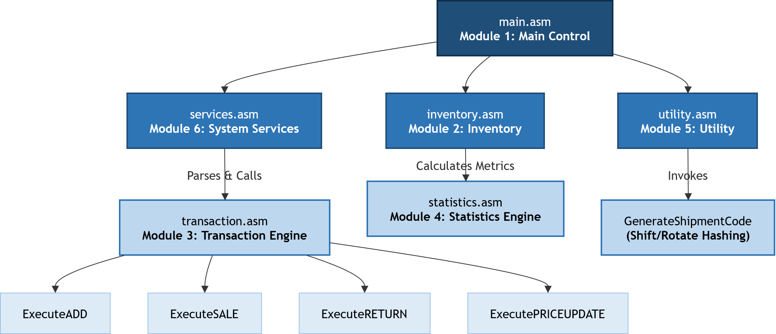
Figure 1 Procedure Hierarchy Diagram

Data Structure Specifications
The system manages inventory records using a static array of structures (STRUCT) aligned to word boundaries.
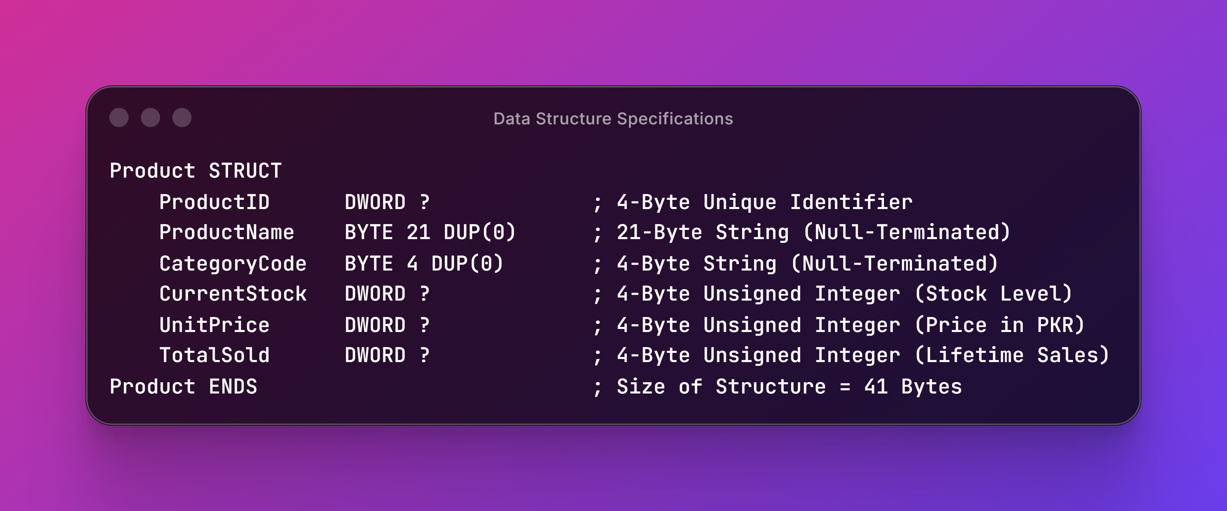

Transaction Logic & Validation State Machines
Each transaction is verified through validation rules to ensure database integrity:
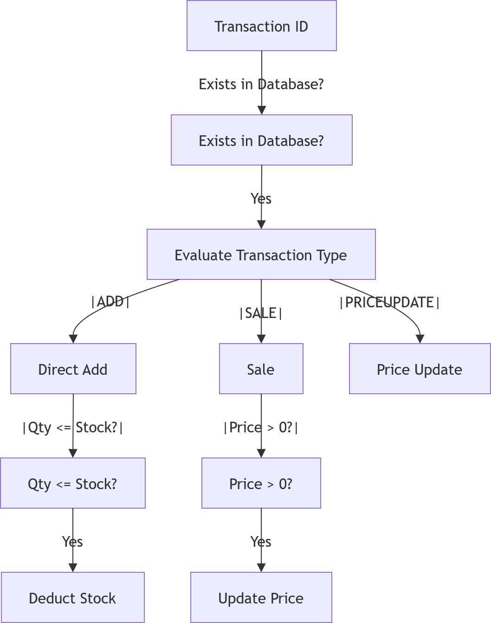

- ADD: Increases the CurrentStock field directly. Negative values are filtered out during standard console parsing.
- SALE: Compares requested quantity against CurrentStock. If Quantity > CurrentStock, the transaction fails, preventing negative stock. Successful sales decrement CurrentStock and increment TotalSold.
- RETURN: Increments CurrentStock. The system decreases TotalSold only if the total remains non-negative.
- PRICEUPDATE: Verifies that the new price is greater than zero before overwriting UnitPrice.

Bitwise Shipment Code Generation
To generate unique tracking codes without using computationally expensive hashing libraries, the system implements bitwise shift and rotate instructions:
Shipment Hash=RotateRight((RotateLeft(ProductID,7)⊕CurrentStock),3)
